**DAILY ONLINE ACTIVITIES SUMMARY**

|  |  |  |  |  |  |  |  |  |
| --- | --- | --- | --- | --- | --- | --- | --- | --- |
| **Date:** | **20-05-2020** | | | | | **Name:** | **Deeksha D Poojary** | |
| **Sem & Sec** | **VIII Semester & A Section** | | | | | **USN:** | **4AL16CS026** | |
| **Online Test Summary** | | | | | | | | |
| **Subject** | | **Internet Of Things** | | | | | | |
| **Max. Marks** | | **30** | | **Score** | | | **26** | |
| **Certification Course Summary** | | | | | | | | |
| **Course** | **Introduction to Hadoop** | | | | | | | |
| **Certificate Provider** | | | **Great Learning** | | **Duration** | | | **One video (8 mins)** |
| **Coding Challenges** | | | | | | | | |
| **Problem Statement: Reverse of the linked list** | | | | | | | | |
| **Status: COMPLETED** | | | | | | | | |
| **Uploaded the report in Github** | | | | | **YES** | | | |
| **If yes Repository name** | | | | | **Deekshapoojari** | | | |
| **Uploaded the report in slack** | | | | | **YES** | | | |

Online Test Details:

Certification Course Details:

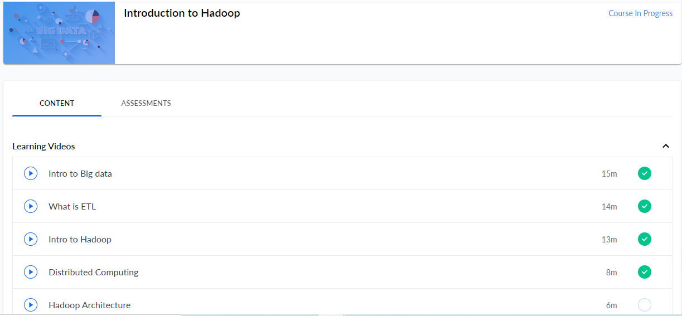

Distributed computing

The Hadoop take a bunch of machines, while installing Hadoop will ask which is master and which is slave. Hadoop is a framework in which we can expand to any number of machine and due to Hadoop the user does not have to worry about the storage because it can resize without downtime. We can add machine and also remove it only if there is no program running in the machine. This whole process is called as Hadoop Clustering. Clustering means group of machines. The Hadoop clusters can also be built in desktops.

Coding Challenges Details:

|  |
| --- |
|  |
|  | **If a linked listis: 1 → 2 → 3 → 4 → 5 → 6 → 7 → 8** |
|  | **The value of size k is 2** |
|  | **Then the linked list looks like: 2 → 1 → 4 → 3 → 6 → 5 → 8 → 7** |
|  |  |
|  |  |
|  | **If a linked listis: 1 → 2 → 3 → 4 → 5 → 6 → 7 → 8** |
|  | **The value of size k is 3** |
|  | **Then the linked list looks like: 3 → 2 → 1 → 6 → 5 → 4 → 8 → 7** |
|  |  |
|  | **Solution:** |
|  |  |
|  | **struct Node** |
|  | **{** |
|  | **int data;** |
|  | **struct Node* next;** |
|  | **};** |
|  | **pointer to the new head node. /** |
|  | **struct Node reverse (struct Node head, int k)** |
|  | **{** |
|  | **struct Node current = head;** |
|  | **struct Node next = NULL;** |
|  | **struct Node prev = NULL;** |
|  | **int count = 0;** |
|  | **while (current != NULL && count < k) { next = current->next; current->next = prev; prev = current; current = next; count++; } if (next != NULL) head->next = reverse(next, k); return prev;** |
|  | **}** |
|  | **void push(struct Node** head_ref, int new_data)** |
|  | **{** |
|  | **struct Node* new_node =** |
|  | **(struct Node*) malloc(sizeof(struct Node));** |
|  | **new_node->data = new_data; new_node->next = (*head_ref); (*head_ref) = new_node;** |
|  | **}** |
|  | **void printList(struct Node *node)** |
|  | **{** |
|  | **while (node != NULL)** |
|  | **{** |
|  | **printf("%d ", node->data);** |
|  | **node = node->next;** |
|  | **}** |
|  | **}** |
|  | **int main(void)** |
|  | **{** |
|  | **struct Node* head = NULL;** |
|  | **push(&head, 8);** |
|  | **push(&head, 7);** |
|  | **push(&head, 6);** |
|  | **push(&head, 5);** |
|  | **push(&head, 4);** |
|  | **push(&head, 3);** |
|  | **push(&head, 2);** |
|  | **push(&head, 1);** |
|  | **printf("\nGiven linked list \n"); printList(head); head = reverse(head, 2);** |
|  | **printf("\nReversed Linked list \n"); printList(head); return(0);** |
|  | **}** |